Chuanjie ZANG

699382953

Step 1 : Select the text using the selection tool, double click on the fil colour in the properties panel on the right and choose a colour I want in the colour mixer.

Step 2 : Then click on swatches, then click on new swatch in the bottom right corner of this panel, change the swatch name to 'text' and click ok.

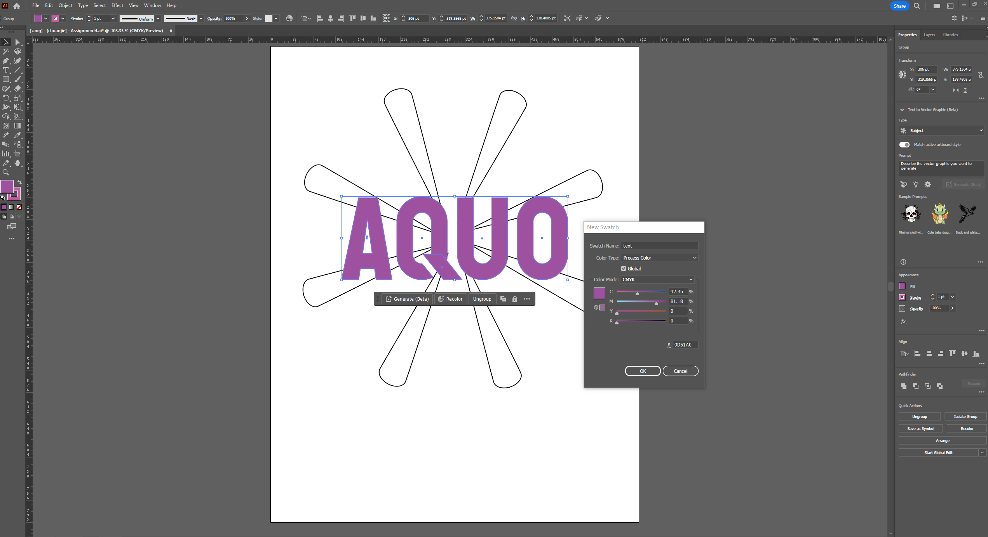

Step 3 : Deselect any text or pattern. Click on 'windows - gradient' in the control bar and drag the text colour in the fill to the 'gradient slider' below, at this point you can drag the control point or click to Adjust the gradient effect.

Step 4 : Open swatches panel, click new swatch, change the name to 'tint of the text', then you can see this gradient effect in swatches panel.

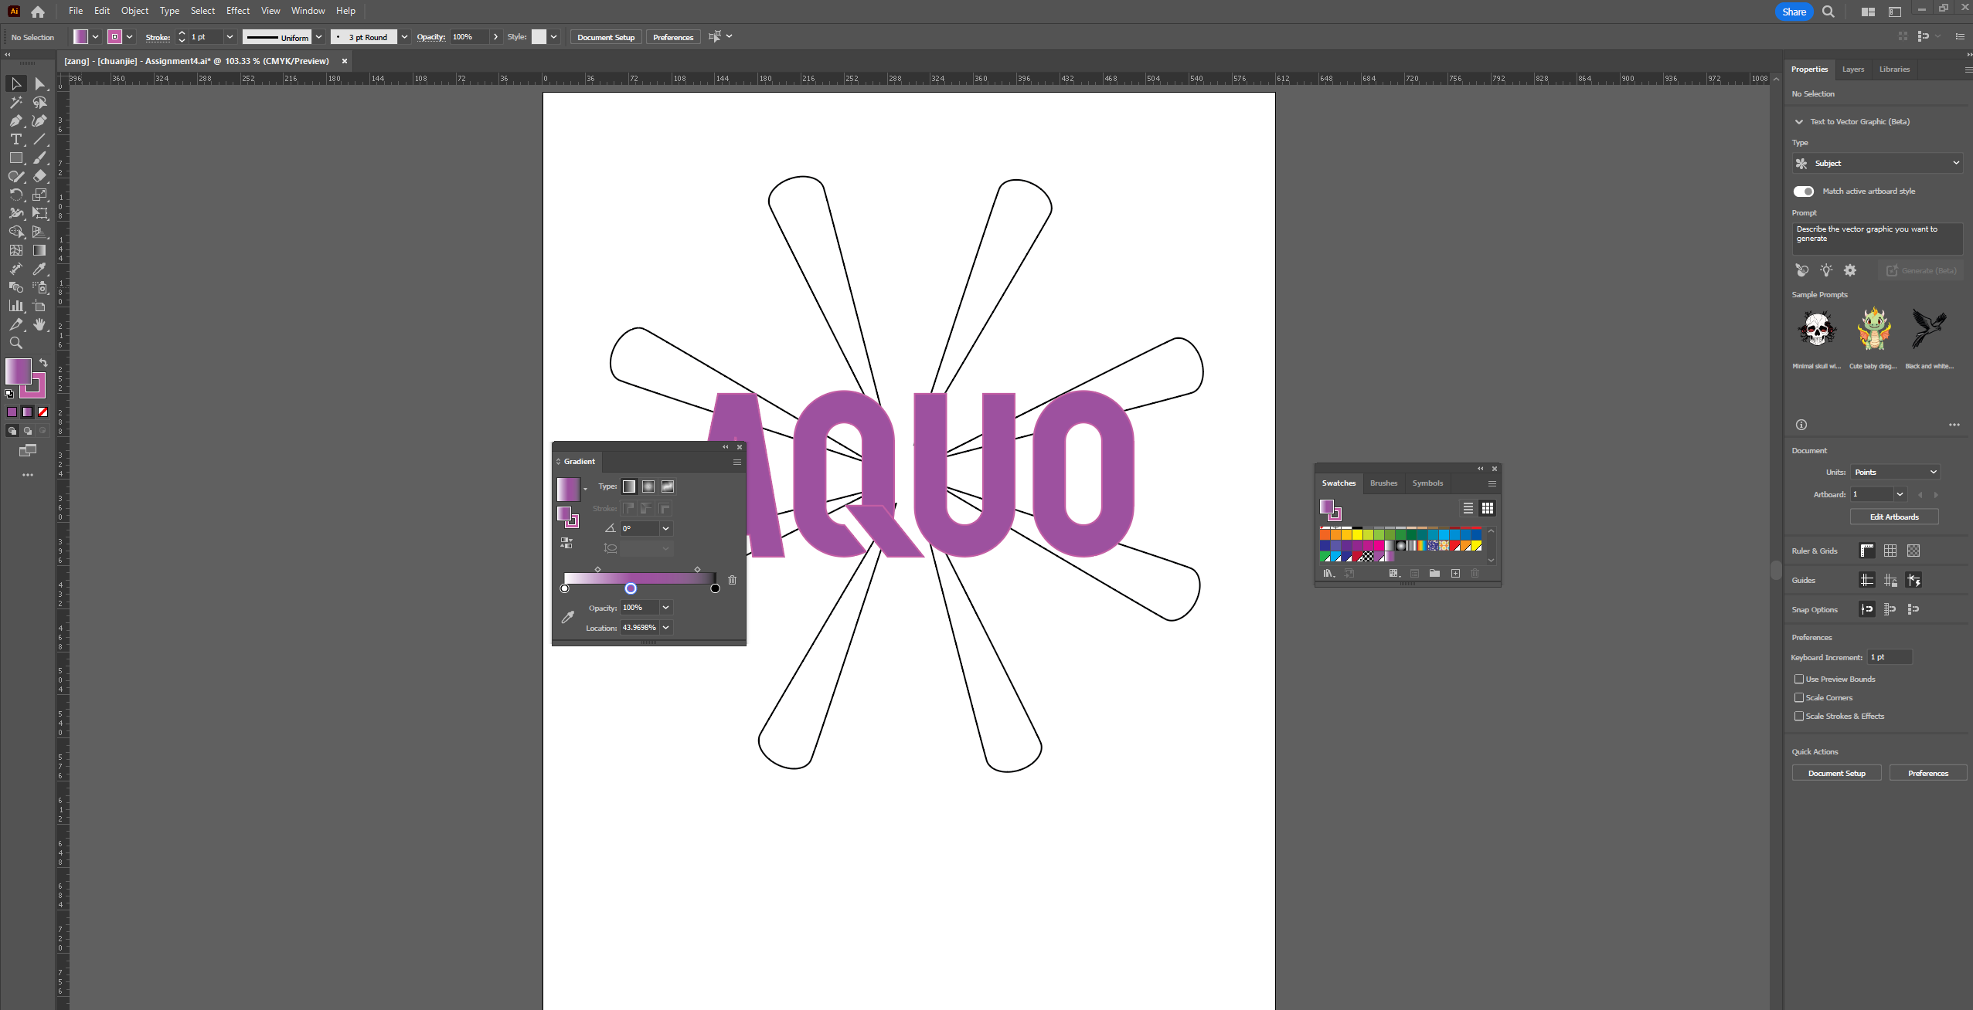

Step 5 :Select the text, click on stroke in the swatches panel, select the 'tint of the text' you just saved and apply this gradient to the stroke of the text. next adjust the stroke to 3pt.

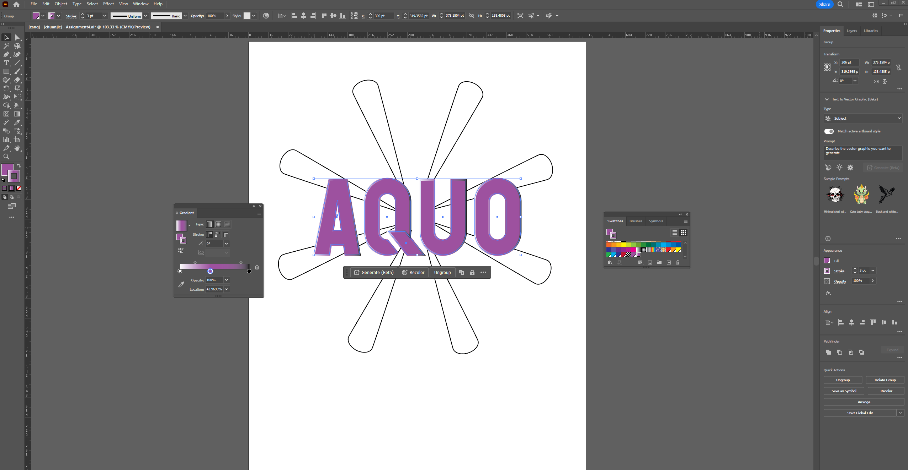

Step 6 :Select any of the shapes using the selection tool and select 'select - same - fill&stroke' in the control bar to select all the shapes. Next select a desired colour in the swatches panel and select new swatch - colour type - spot colour and click ok.

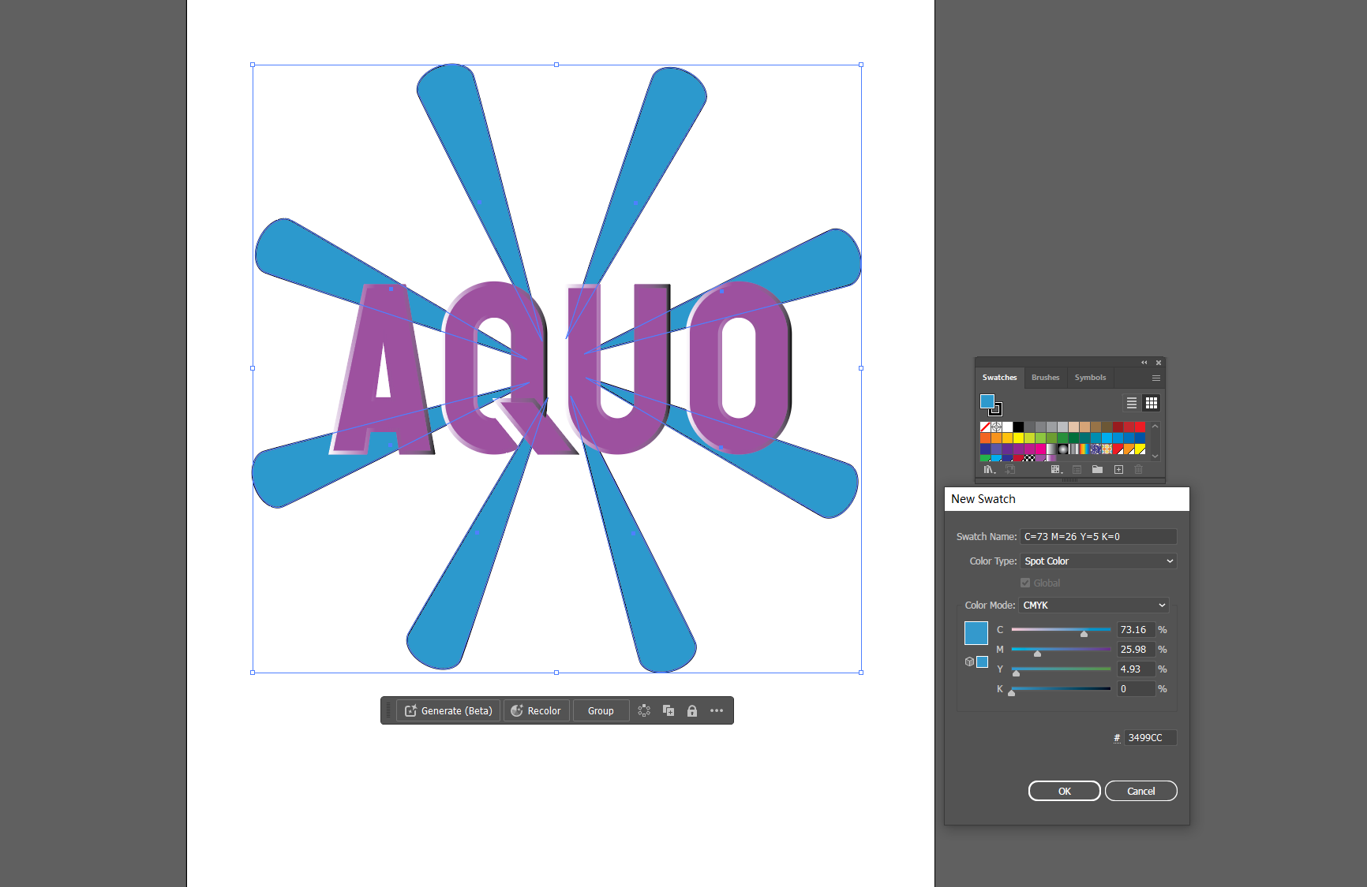

Step 7 :In the swatches panel, click on 'show list view' in the top right corner, then use the shift key to select the 2 colours you have just created, then click on new colour group in the bottom right corner of the swatches panel and name it 'assignment4'.